InformAG Technical Assessment – Azure DevOps Engineer

- Secure & Scalable Azure Architecture.
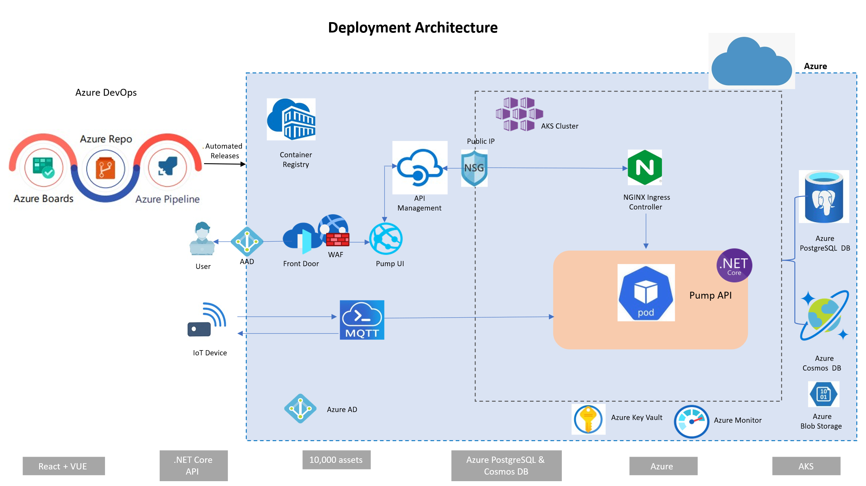
Architecture Components:
- IoT Devices: Pumps sending telemetry via MQTT
- Azure IoT Hub: Central MQTT broker
- Azure Kubernetes Service (AKS): Hosts containerized API & backend services
- Docker: Containerize .NET Core APIs
- Azure Container Registry (ACR): Stores container images
- Azure Cosmos DB / Azure SQL / Azure Blob Storage: Stores structured and unstructured pump metadata
- WAF: Secures and routes web/mobile traffic
- Azure AD B2C: Provides multi-tenant authentication
- Azure Key Vault: Secure secrets and certificates.
- Azure Front Door: CDN and global load balancing

- Automated Monitoring & Anomaly Detection
Monitoring Stack:
- Azure Monitor: Infrastructure metrics
- Application Insights: API telemetry, tracing, failures
- Log Analytics: Query logs across services
Anomaly Detection:
- Stream Analytics: Detect thresholds (e.g., temperature & pressure)
- Azure Metrics.
- Alerts & Notifications:
  - Azure Monitor Alerts + Action Groups
  - Email, SMS, or Azure Logic Apps/Functions

- Build Pipeline:
- The Azure DevOps pipeline builds the Docker image of C# backend API from the Docker file.
- Pushes the image to Azure Container Registry (ACR).
- Deploys the image as a container to Azure Kubernetes Service (AKS) using a blue-green method. The Kubernetes service points to the active environment based on the requirement.

Blue/Green Setup:
We are maintaining 2 Kubernetes Deployments:
- pumpmaster-blue and pumpmaster-green.
- Here the kubernetes service routes the traffic by the label "app".
  - app: pumpmaster-blue or app: pumpmaster-green
Smoke Tests: health checks which tests the APIs.
Rollback: If green fails, the traffic still flows to blue. No actual "swap" happens unless we make change manually in the last stage.
Blue/Green switching:
- Deploy to pumpmaster-green.
- Run health checks.
- If green is healthy, update the service
  - "kubectl set selector svc/pumpmaster-service app=pumpmaster-green"
- If rollback required,
  - "kubectl set selector svc/pumpmaster-service app=pumpmaster-blue"

- Troubleshooting & Security Incident Response
Scenario: Pump sending data, but not visible in frontend.
Troubleshooting Steps:
- IoT Hub:
  - Check device update time
  - Validate ingestion logs of telemetry
  - Check error logs or dropped messages
- Data Layer (Cosmos DB / SQL):
  - Inspect by Query for recent writes.
- API Layer:
  - Check Application Insights for failed API calls and the response codes.
- Frontend:
  - Validate API call responses
  - Ensure no filters are hiding the data

- Security Considerations:
- Secure IoT devices with certs or SAS tokens
- Use TLS 1.2+ for MQTT and API traffic.
- RBAC in AKS and Azure.
- Store secrets in Azure Key Vault with strict access controls.

